Task Description-1: -
Use AI to generate test cases for is_valid_email(email) and then implement the
validator function.
Requirements:
• Must contain @ and . characters.
• Must not start or end with special characters.
• Should not allow multiple @.
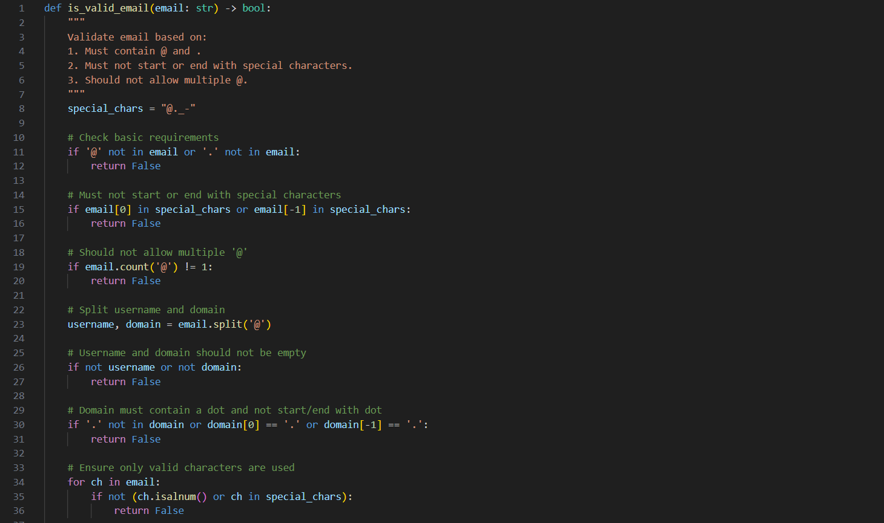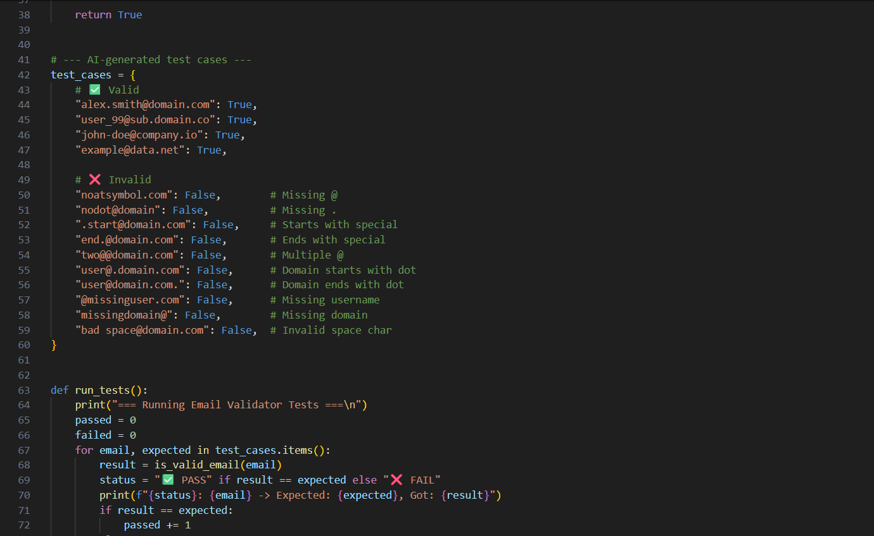
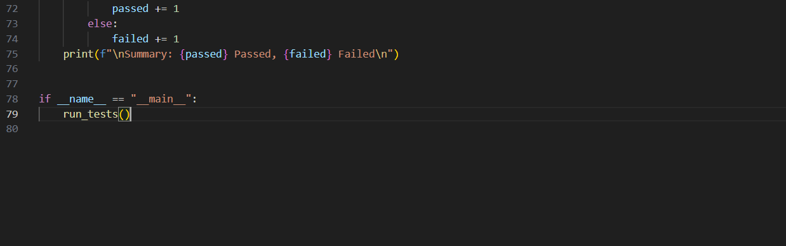
Practical Output: -
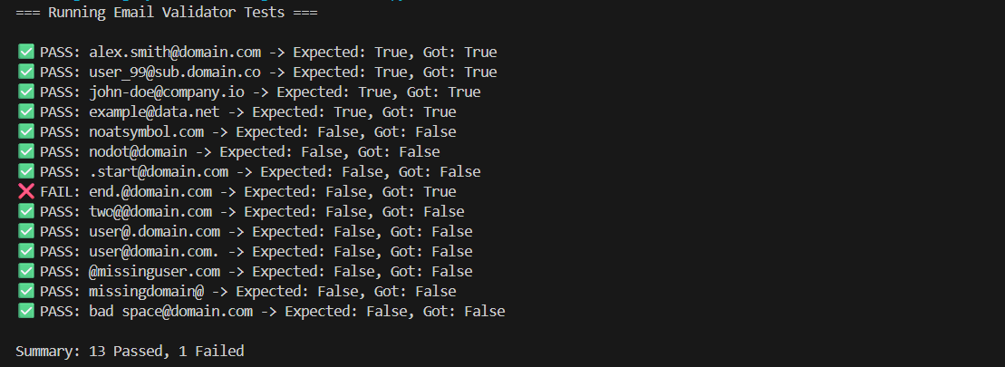
Explanation: -The function is_valid_email(email: str) -> bool checks if a given string is a valid email address based on a few rules.
The rules enforced are:
The email must contain @ and ..
It must not start or end with special characters like ., _, @, or -.
It should contain only one @ symbol.
The username and domain parts must not be empty.
The domain must contain at least one dot (.) and must not start or end with a dot.
The email can contain only alphanumeric characters or valid special characters (@._-).

1. Define special characters
special_chars = "@._-"
This defines which special characters are allowed in the email.

2. Check if @ and . are present
if '@' not in email or '.' not in email:
return False
If either @ or . is missing, it's immediately invalid.

3. Check if email starts or ends with a special character
if email[0] in special_chars or email[-1] in special_chars:
return False
Emails like .alex@domain.com or alex@domain.com- are invalid.

4. Ensure only one @ symbol
if email.count('@') != 1:
return False
Emails like user@@domain.com are invalid.

5. Split into username and domain
username, domain = email.split('@')
Example:
alex.smith@domain.com →
username = "alex.smith", domain = "domain.com"

6. Ensure both username and domain exist
if not username or not domain:
return False
Emails like @domain.com or user@ are invalid.

7. Validate domain formatting
if '.' not in domain or domain[0] == '.' or domain[-1] == '.':
return False
The domain must have at least one . (like domain.com), but not start or end with it.
Examples:
✅ domain.com → OK
❌ .domain.com → Invalid
❌ domain.com. → Invalid

8. Validate all characters
for ch in email:
if not (ch.isalnum() or ch in special_chars):
return False
This ensures only allowed characters (letters, numbers, or @._-) are used.
So bad space@domain.com or user!@domain.com → ❌ Invalid

9. Return True if all checks pass
return True

🧪 Testing Section
test_cases = {
...
}
This dictionary contains various email examples and whether they are expected to be valid (True) or invalid (False).

10. Run tests
def run_tests():
...
This function loops through each test case, calls is_valid_email(email), and compares the result with the expected value.
It prints:
✅ PASS if the result matches
❌ FAIL if it doesn’t
Task Description-2: -
Ask AI to generate test cases for assign_grade(score) function. Handle boundary and
invalid inputs.
Requirements:-
-AI should generate test cases for assign_grade(score) where: 90-100: A, 80-89: B, 70-
79: C, 60-69: D, <60: F
-Include boundary values and invalid inputs (e.g., -5, 105, "eighty").
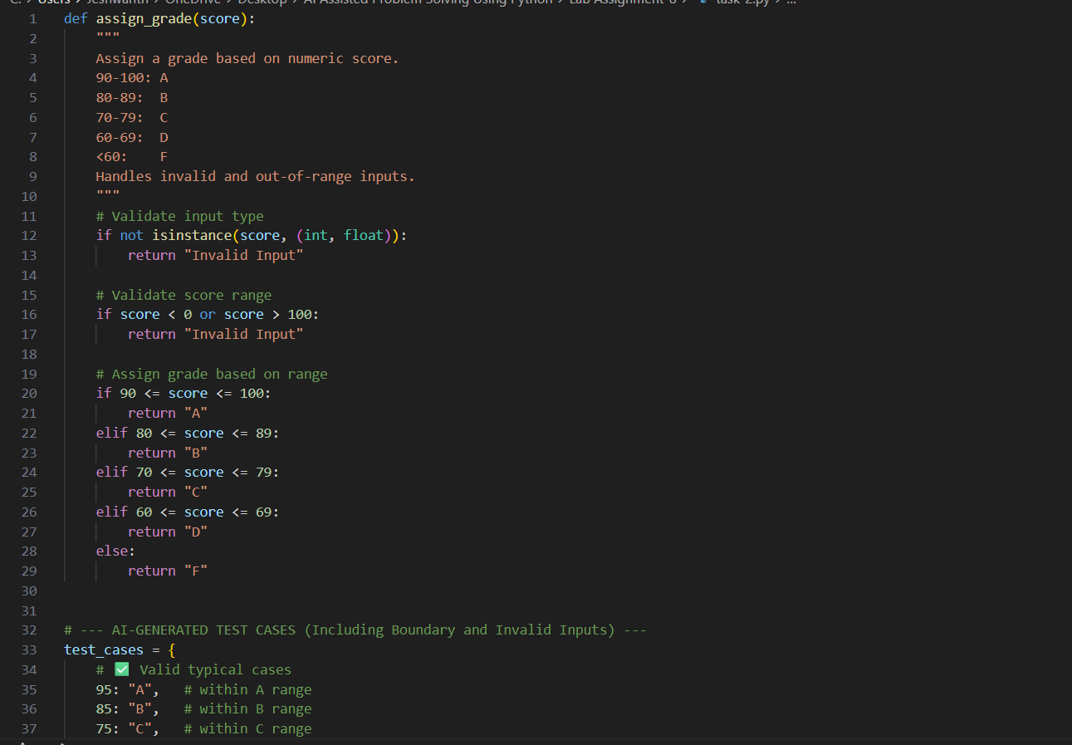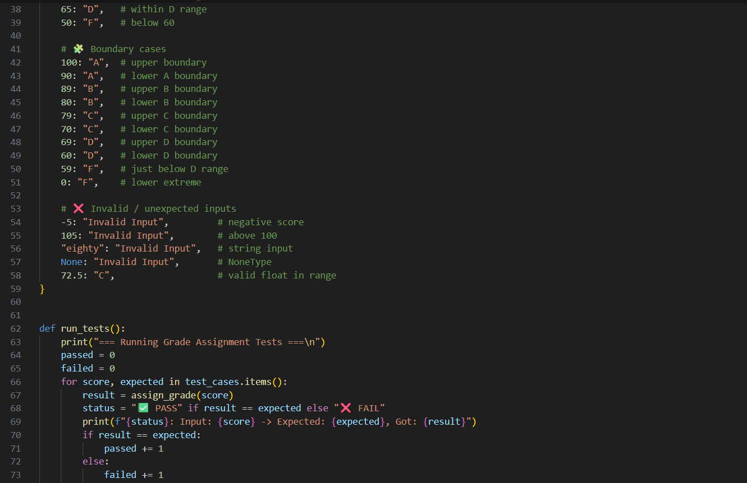
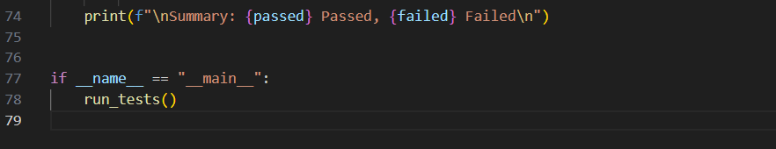
Practical Output: -
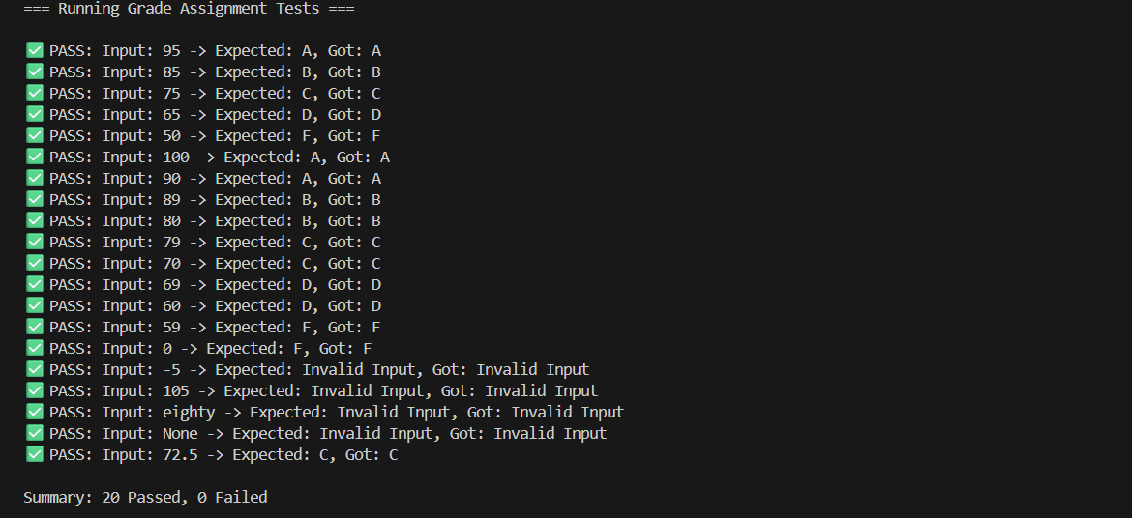
Explanation: -
The goal of this program is to assign a letter grade (A, B, C, D, or F) based on a numeric score between 0 and 100.
It also handles invalid inputs like:
Numbers outside the valid range (e.g., -5, 105)
Non-numeric values (e.g., "eighty", None)

🧩 Function: assign_grade(score)
1. Docstring (Explanation in Comments)
"""
Assign a grade based on numeric score.
90-100: A
80-89: B
70-79: C
60-69: D
<60: F
Handles invalid and out-of-range inputs.
"""
This describes:
The grading scale.
The function’s behavior.
The fact that it checks for invalid inputs.

2. Input Type Validation
if not isinstance(score, (int, float)):
return "Invalid Input"
✅ Checks that the input is a number (either an integer or a float).
❌ Returns "Invalid Input" if it’s not (e.g., "eighty", None).

3. Range Validation
if score < 0 or score > 100:
return "Invalid Input"
✅ Ensures that only scores between 0 and 100 are valid.
❌ Returns "Invalid Input" if the score is negative or above 100.

4. Grade Assignment Using Conditional Statements
The function checks which numeric range the score falls into and returns the corresponding letter grade.
if 90 <= score <= 100:
return "A"
elif 80 <= score <= 89:
return "B"
elif 70 <= score <= 79:
return "C"
elif 60 <= score <= 69:
return "D"
else:
return "F"
🧠 Explanation of each range:
90–100 → A
80–89 → B
70–79 → C
60–69 → D
Below 60 → F
The use of <= ensures inclusive boundaries (e.g., 90 counts as an A).

🧪 Test Cases
The dictionary test_cases defines input values and their expected outputs.
✅ Valid Typical Cases
95: "A"
85: "B"
75: "C"
65: "D"
50: "F"
These are standard cases well within each grade range.

🧩 Boundary Cases
100: "A"
90: "A"
89: "B"
80: "B"
79: "C"
70: "C"
69: "D"
60: "D"
59: "F"
0: "F"
These test the edges of each range to make sure the boundaries work properly.
For example:
90 → A (lower A boundary)
89 → B (upper B boundary)
60 → D (lower D boundary)
59 → F (just below D range)

❌ Invalid / Unexpected Inputs
-5: "Invalid Input" # Below 0
105: "Invalid Input" # Above 100
"eighty": "Invalid Input" # Not a number
None: "Invalid Input" # Missing value
72.5: "C" # Valid float between 70–79
This tests type checking and range validation.
Note that 72.5 is valid and falls in the C range.

⚙️ Test Runner: run_tests()
This function automatically tests all the above cases.
Step-by-step:
Loops through each test case:
for score, expected in test_cases.items():
Calls the function:
result = assign_grade(score)
Compares the actual result with the expected result.
Prints either:
✅ PASS — if it matches
❌ FAIL — if it doesn’t
Counts passed/failed tests.
Prints a summary.

Task Description-3: -
- Generate test cases using AI for is_sentence_palindrome(sentence). Ignore case,
punctuation, and spaces
Requirement
-Ask AI to create test cases for is_sentence_palindrome(sentence)
(ignores case, spaces, and punctuation).
-Example:
"A man a plan a canal Panama" → True
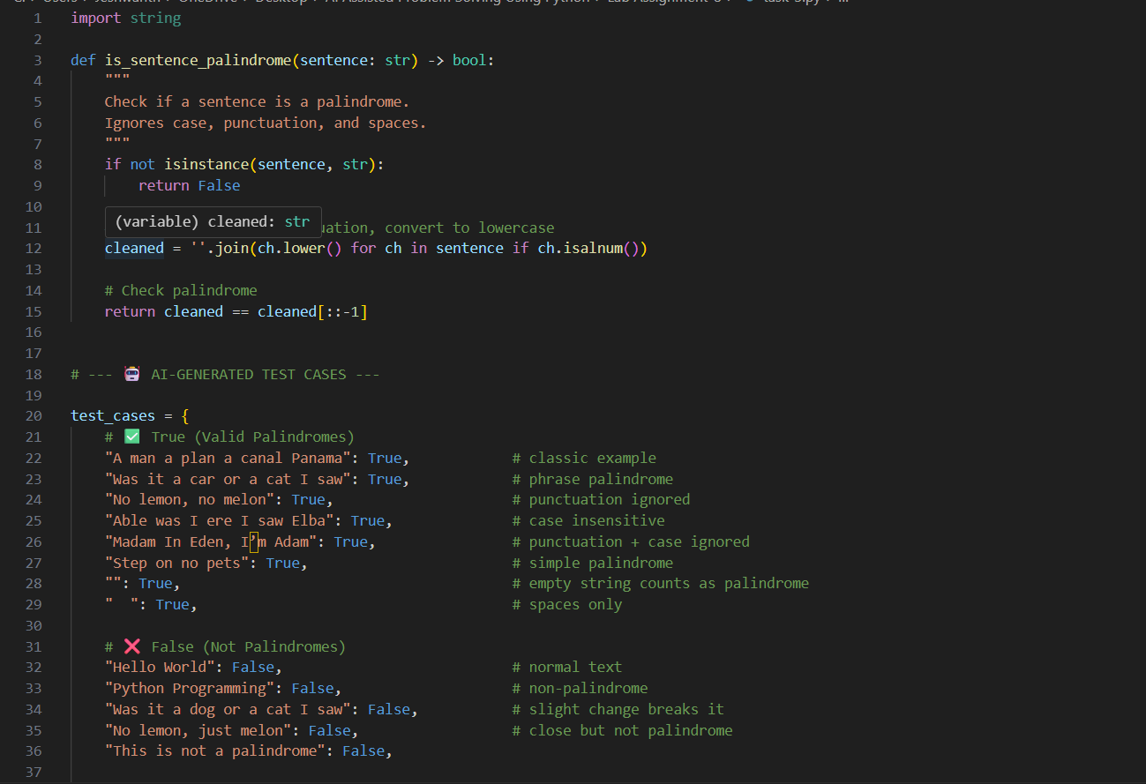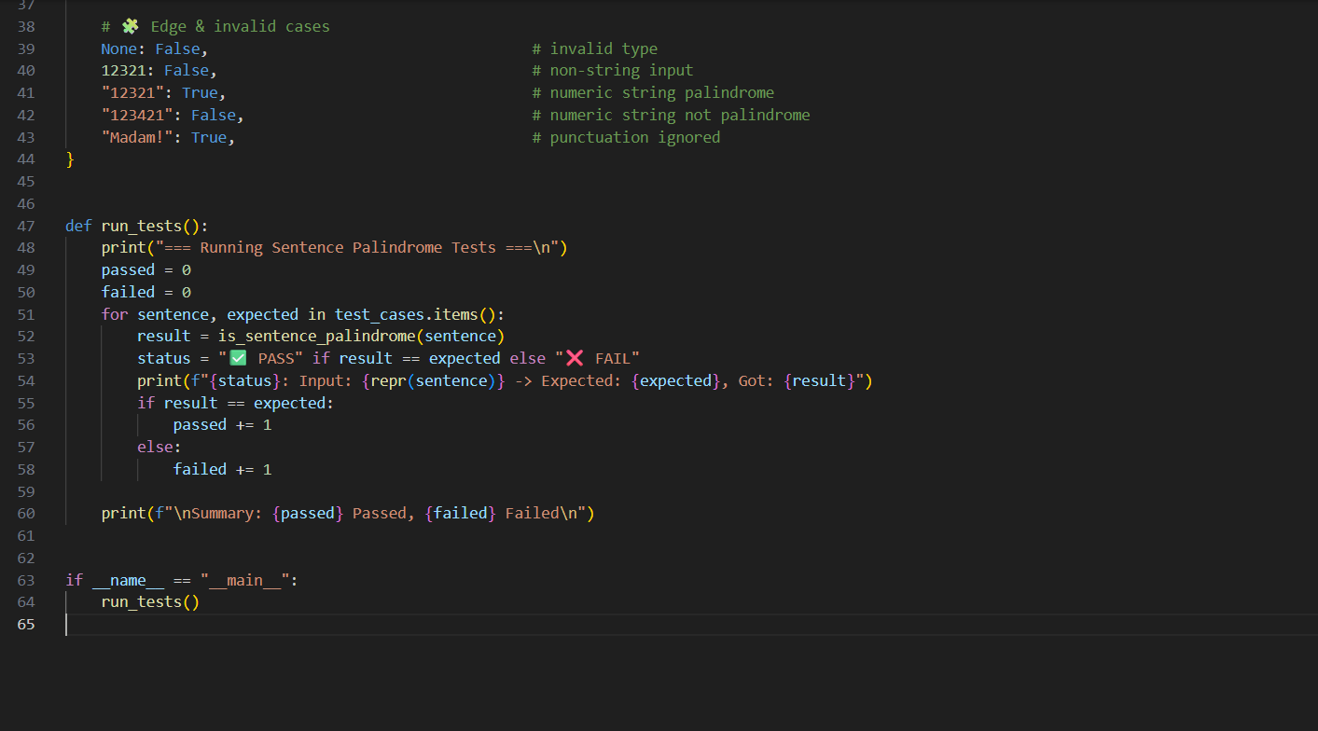

Practical Output: -
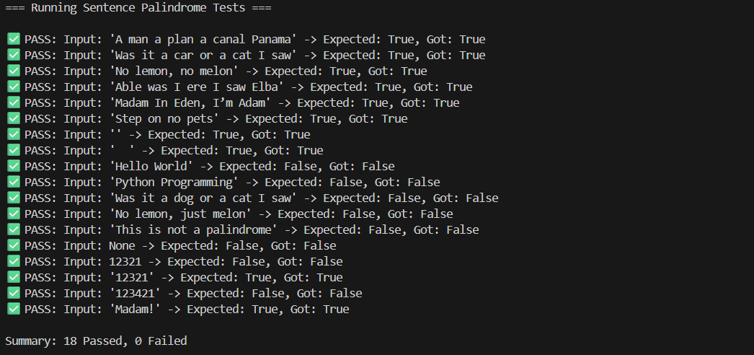
Explanation: -
The program defines a function is_sentence_palindrome(sentence) that checks if a given sentence is a palindrome, meaning it reads the same forwards and backwards — ignoring case, spaces, and punctuation.
It also includes a test suite to verify the function with various cases.

🧩 1. Function Definition
def is_sentence_palindrome(sentence: str) -> bool:
"""
Check if a sentence is a palindrome.
Ignores case, punctuation, and spaces.
"""
This docstring explains:
What the function does (checks for palindrome).
That it ignores case, punctuation, and spaces.
So “A man, a plan, a canal, Panama” → ✅ Palindrome.

🧠 2. Type Validation
if not isinstance(sentence, str):
return False
Ensures the input is a string.
If you pass something like None, 12321, or a list, it returns "False".
Defensive programming: prevents errors when .lower() or .isalnum() is used later.
Example:
is_sentence_palindrome(12321) → False

🧹 3. Cleaning the Sentence
cleaned = ''.join(ch.lower() for ch in sentence if ch.isalnum())
Let’s break that down:
ch.isalnum() → keeps only letters and digits, removing spaces, punctuation, and symbols.
ch.lower() → converts to lowercase to ignore case differences.
''.join(...) → concatenates all valid characters into one clean string.
Example:
Input: "A man, a plan, a canal, Panama"
After cleaning:
cleaned = "amanaplanacanalpanama"

🔁 4. Checking for Palindrome
return cleaned == cleaned[::-1]
cleaned[::-1] reverses the string.
If the cleaned string is the same forwards and backwards → it’s a palindrome.
Example:
"amanaplanacanalpanama" == "amanaplanacanalpanama" → True

🧪 5. Test Cases
test_cases = { ... }
These test cases verify correctness across a wide range of situations.
✅ True (Valid Palindromes)
Input | Reason
"A man a plan a canal Panama" | Classic palindrome ignoring spaces & punctuation
"Was it a car or a cat I saw" | Reads the same backward
"No lemon, no melon" | Punctuation ignored
"Able was I ere I saw Elba" | Famous phrase palindrome
"Madam In Eden, I’m Adam" | Case & punctuation ignored
"Step on no pets" | Simple, clean palindrome
"" | Empty string counts as palindrome (same forward/backward)
" " | Only spaces → cleaned to empty → palindrome

❌ False (Not Palindromes)
Input | Why
"Hello World" | Not symmetrical
"Python Programming" | Not palindrome
"Was it a dog or a cat I saw" | Slight change breaks it
"No lemon, just melon" | Not matching reversed
"This is not a palindrome" | Self-explanatory

🧩 Edge & Invalid Cases
Input | Expected | Reason
None | False | Invalid (not string)
12321 | False | Non-string type (int)
"12321" | True | Numeric palindrome string
"123421" | False | Not symmetrical
"Madam!" | True | Punctuation ignored

⚙️ 6. Test Runner
def run_tests():
...
This function automates checking all test cases.
Step-by-step:
Iterates over each test case:
for sentence, expected in test_cases.items():
Runs the function:
result = is_sentence_palindrome(sentence)
Compares actual vs. expected output.
Prints:
✅ PASS — if correct.
❌ FAIL — if not.
Counts passed and failed tests.
Displays summary at the end.

Task Description-4:-
-Let AI fix it Prompt AI to generate test cases for a ShoppingCart class (add_item,
remove_item, total_cost).
-Methods:
Add_item(name,orice)
Remove_item(name)
Total_cost()
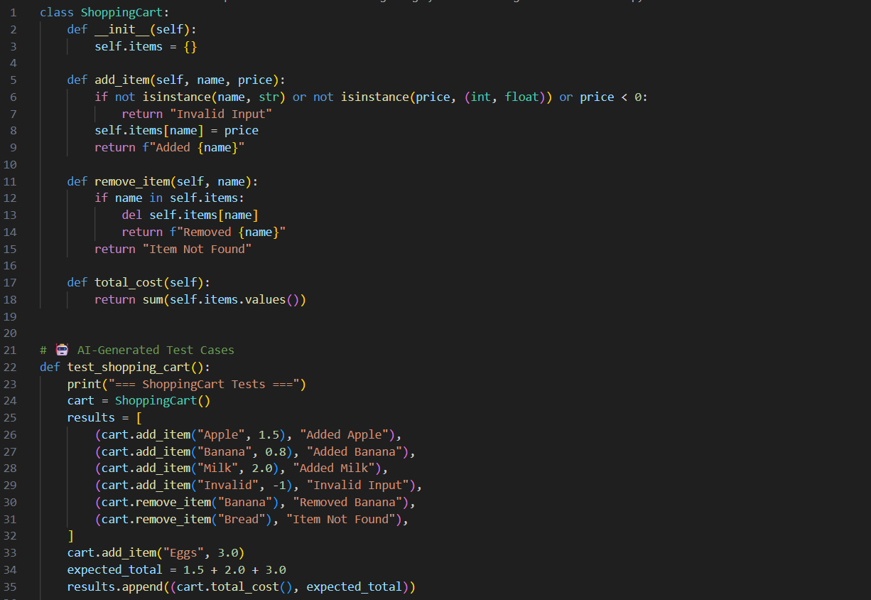
Practical Output: -
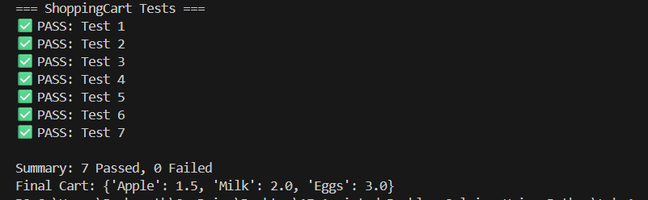
Explanation: -
The program defines a ShoppingCart class that allows you to:
Add items with a name and price.
Remove items by name.
Compute the total cost of items in the cart.
It also includes a test function to verify that the class behaves correctly.

🧩 1. Class Definition
class ShoppingCart:
def __init__(self):
self.items = {}
self.items is a dictionary where:
Key → item name (string)
Value → item price (number)
Empty cart initially.
Example:
cart = ShoppingCart()
cart.items # {}

2. Adding Items
def add_item(self, name, price):
if not isinstance(name, str) or not isinstance(price, (int, float)) or price < 0:
return "Invalid Input"
self.items[name] = price
return f"Added {name}"
Step-by-step:
Input Validation
name must be a string.
price must be a number (int or float) and non-negative.
Returns "Invalid Input" if any condition fails.
Add/Update Item
Adds the item to self.items.
If the item already exists, price is overwritten.
Confirmation
Returns a string like "Added Apple" for success.
Examples:
cart.add_item("Apple", 1.5) # "Added Apple"
cart.add_item("Banana", -1) # "Invalid Input"

3. Removing Items
def remove_item(self, name):
if name in self.items:
del self.items[name]
return f"Removed {name}"
return "Item Not Found"
Checks if the item exists in self.items.
Deletes it if present, otherwise returns "Item Not Found".
Example:
cart.remove_item("Banana") # "Removed Banana"
cart.remove_item("Bread") # "Item Not Found"

4. Total Cost Calculation
def total_cost(self):
return sum(self.items.values())
Adds up all prices in the dictionary.
Returns a numeric total.
Example:
cart.items = {"Apple": 1.5, "Milk": 2.0}
cart.total_cost() # 3.5

🧪 5. Test Cases
The test_shopping_cart() function runs a series of tests to verify functionality.
cart = ShoppingCart()
Start with an empty cart.

✅ Test Steps
Add valid items:
(cart.add_item("Apple", 1.5), "Added Apple")
(cart.add_item("Banana", 0.8), "Added Banana")
(cart.add_item("Milk", 2.0), "Added Milk")
Should return the "Added ..." confirmation for each.
Add invalid item:
(cart.add_item("Invalid", -1), "Invalid Input")
Negative price → should return "Invalid Input".
Remove items:
(cart.remove_item("Banana"), "Removed Banana")
(cart.remove_item("Bread"), "Item Not Found")
"Banana" exists → removed.
"Bread" doesn’t exist → "Item Not Found".
Add more items for total:
cart.add_item("Eggs", 3.0)
Calculate expected total:
expected_total = 1.5 + 2.0 + 3.0 # Apple + Milk + Eggs
"Banana" was removed.
"Invalid" wasn’t added.
Compare function results vs expected output:
results = [
# ... results of add/remove
(cart.total_cost(), expected_total)
]

✅ 6. Test Runner Logic
passed, failed = 0, 0
for i, (result, expected) in enumerate(results, 1):
print(f"{'✅ PASS' if result == expected else '❌ FAIL'}: Test {i}")
if result == expected: passed += 1
else: failed += 1
Loops through all results.
Prints PASS/FAIL for each test.
Counts totals.
print("Final Cart:", cart.items)
Displays the final state of the cart dictionary:
{"Apple": 1.5, "Milk": 2.0, "Eggs": 3.0}

🧠 Summary Table of Features
Method | Purpose | Example | Output
add_item(name, price) | Adds item to cart | "Apple", 1.5 | "Added Apple"
remove_item(name) | Removes item if exists | "Banana" | "Removed Banana"
total_cost() | Sums all item prices | {"Apple":1.5,"Milk":2.0} | 3.5
Input Validation:
Names must be strings.
Prices must be non-negative numbers.
Cart Behaviour:
Adding an existing item overwrites price.
Removing non-existing items gives "Item Not Found".
Total only counts currently in-cart items.

Task Description-5: -
• Use AI to write test cases for convert_date_format(date_str) to switch from "YYYY-
MM-DD" to "DD-MM-YYYY".
Example: "2023-10-15" → "15-10-2023"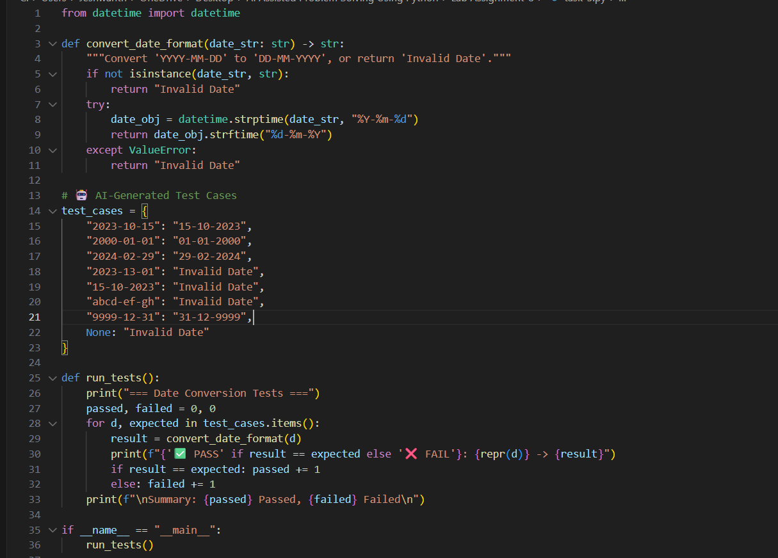
Practical Output: -
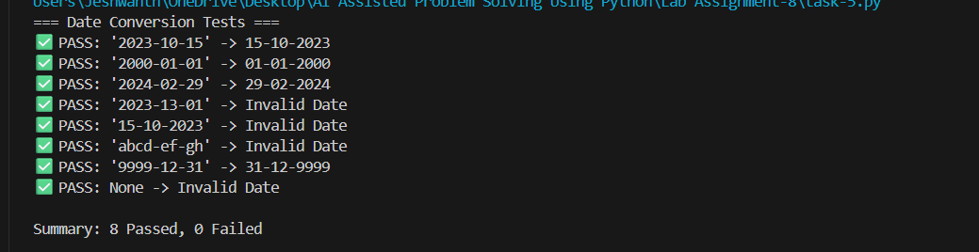
Explanation: -
The function convert_date_format:
Takes a date string in YYYY-MM-DD format.
Converts it to DD-MM-YYYY format.
Returns "Invalid Date" for:
Incorrect types
Invalid date strings
Dates not in YYYY-MM-DD format

🧩 1. Function Definition
def convert_date_format(date_str: str) -> str:
"""Convert 'YYYY-MM-DD' to 'DD-MM-YYYY', or return 'Invalid Date'."""
The function expects a string (date_str) as input.
Output is also a string: either the reformatted date or "Invalid Date".

2. Type Check
if not isinstance(date_str, str):
return "Invalid Date"
Ensures input is a string.
If input is something else (None, int, list, etc.), immediately returns "Invalid Date".

3. Parsing the Date
try:
date_obj = datetime.strptime(date_str, "%Y-%m-%d")
Uses datetime.strptime() to parse the input string.
Format %Y-%m-%d means:
%Y → 4-digit year
%m → 2-digit month (01-12)
%d → 2-digit day (01-31)
If the input string does not match this format or represents an invalid date (like 2023-13-01), it raises a ValueError.

4. Formatting the Date
return date_obj.strftime("%d-%m-%Y")
Converts the datetime object into a string in DD-MM-YYYY format.
%d → day, %m → month, %Y → year.
Example:
datetime.strptime("2023-10-15", "%Y-%m-%d").strftime("%d-%m-%Y")
# "15-10-2023"

5. Error Handling
except ValueError:
return "Invalid Date"
Catches invalid format or impossible dates.
Returns "Invalid Date" if parsing fails.

🧪 6. Test Cases
Your AI-generated test cases check different scenarios:
Input | Expected | Reason
"2023-10-15" | "15-10-2023" | Standard valid date
"2000-01-01" | "01-01-2000" | Another valid date
"2024-02-29" | "29-02-2024" | Leap year valid date
"2023-13-01" | "Invalid Date" | Invalid month (13)
"15-10-2023" | "Invalid Date" | Wrong format (not YYYY-MM-DD)
"abcd-ef-gh" | "Invalid Date" | Completely invalid string
"9999-12-31" | "31-12-9999" | Extreme valid date
None | "Invalid Date" | Wrong type
✅ These cover valid dates, format errors, invalid values, and type errors.

7. Test Runner
for d, expected in test_cases.items():
result = convert_date_format(d)

print(f"{'✅ PASS' if result == expected else '❌ FAIL'}: {repr(d)} -> {result}")
Loops through each test case.
Compares actual result to expected.
Prints PASS/FAIL for each.
print(f"\nSummary: {passed} Passed, {failed} Failed\n")
Counts how many tests passed vs failed.

